Tableau is a powerful data visualization tool that allows users to view data in an easy to understand way. It enables users to create a wide range of visualizations, from simple charts to complex dashboards, by dragging and dropping data fields onto a canvas. Tableau supports real-time data analysis, making it possible to explore large datasets and uncover insights quickly.

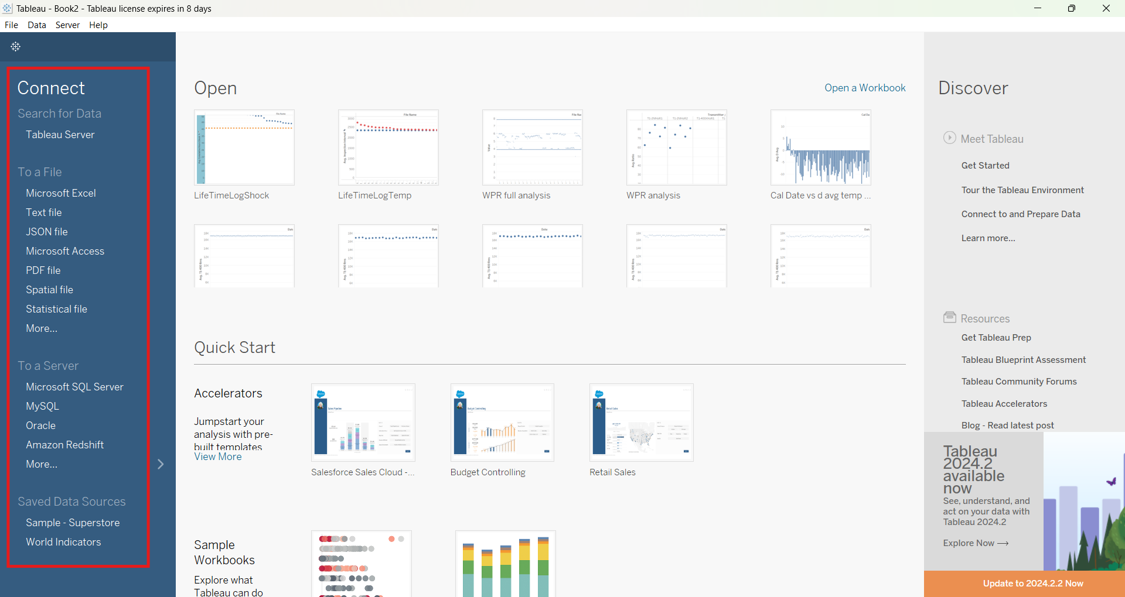

After opening Tableau, connect to a data source. Tableau supports a wide range of data sources that they have listed under the “Connect” header. Then, click on sheet 1 at the bottom of the new window to view the data.

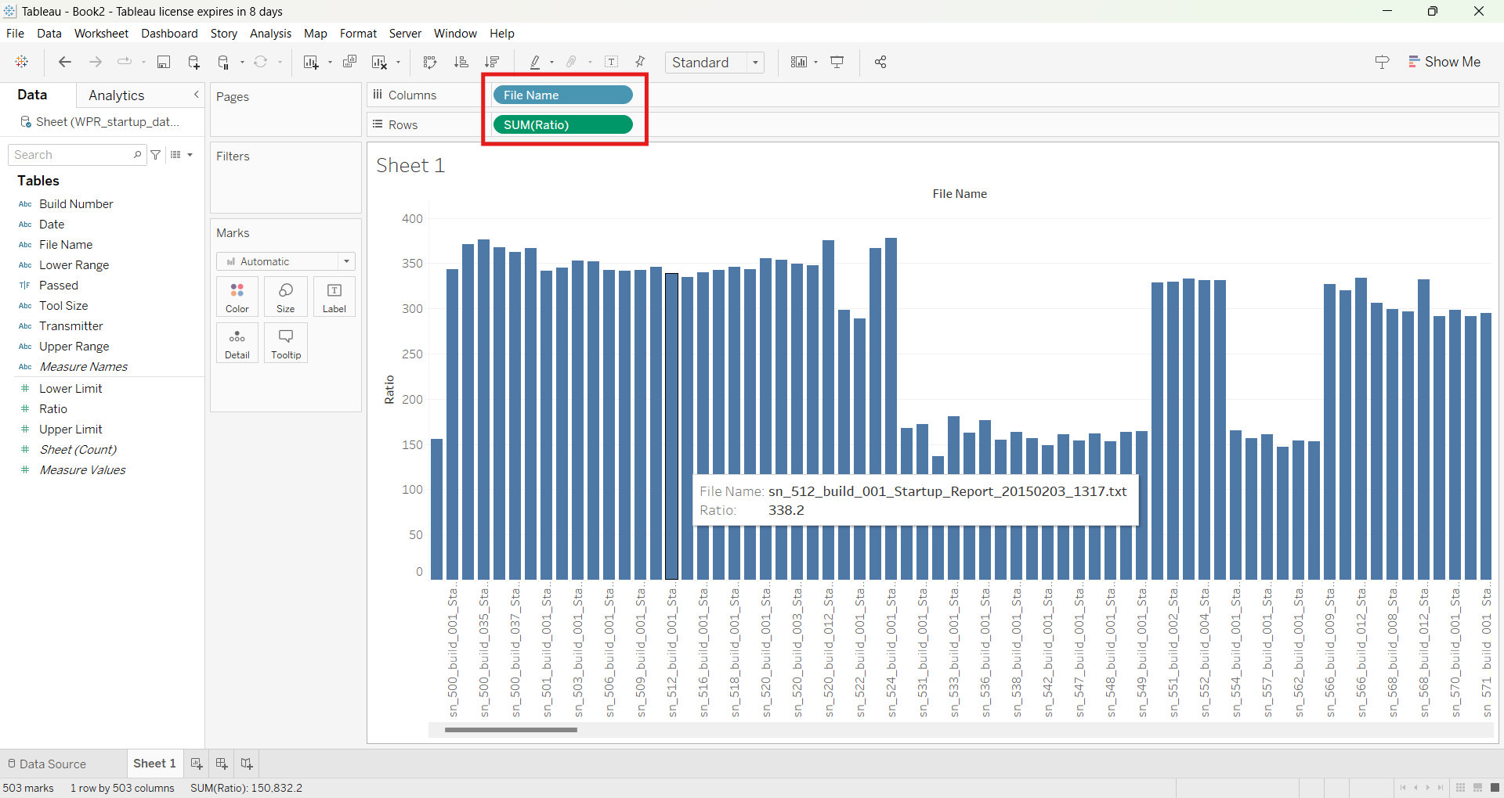

Drag and drop different dimensions and measures into the rows and columns to create graphs.

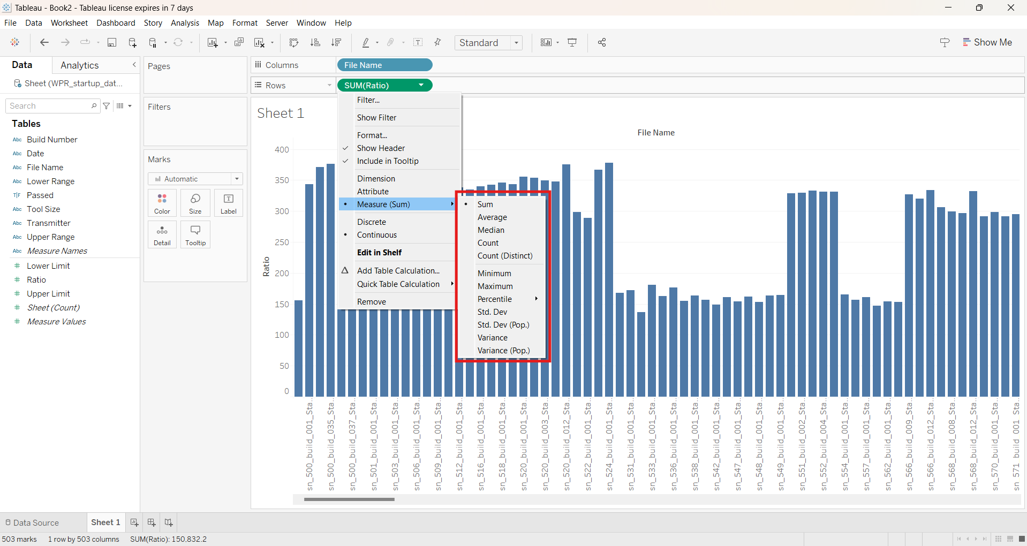

When selecting a measure it will automatically be a sum. You can switch the measure to an average, median, or count by clicking on the arrow on the right side of the measure and then clicking, “Measure (Sum)”.

If there is more data than what fits in the screen, click the box labled “Standard” to switch the view of the data. 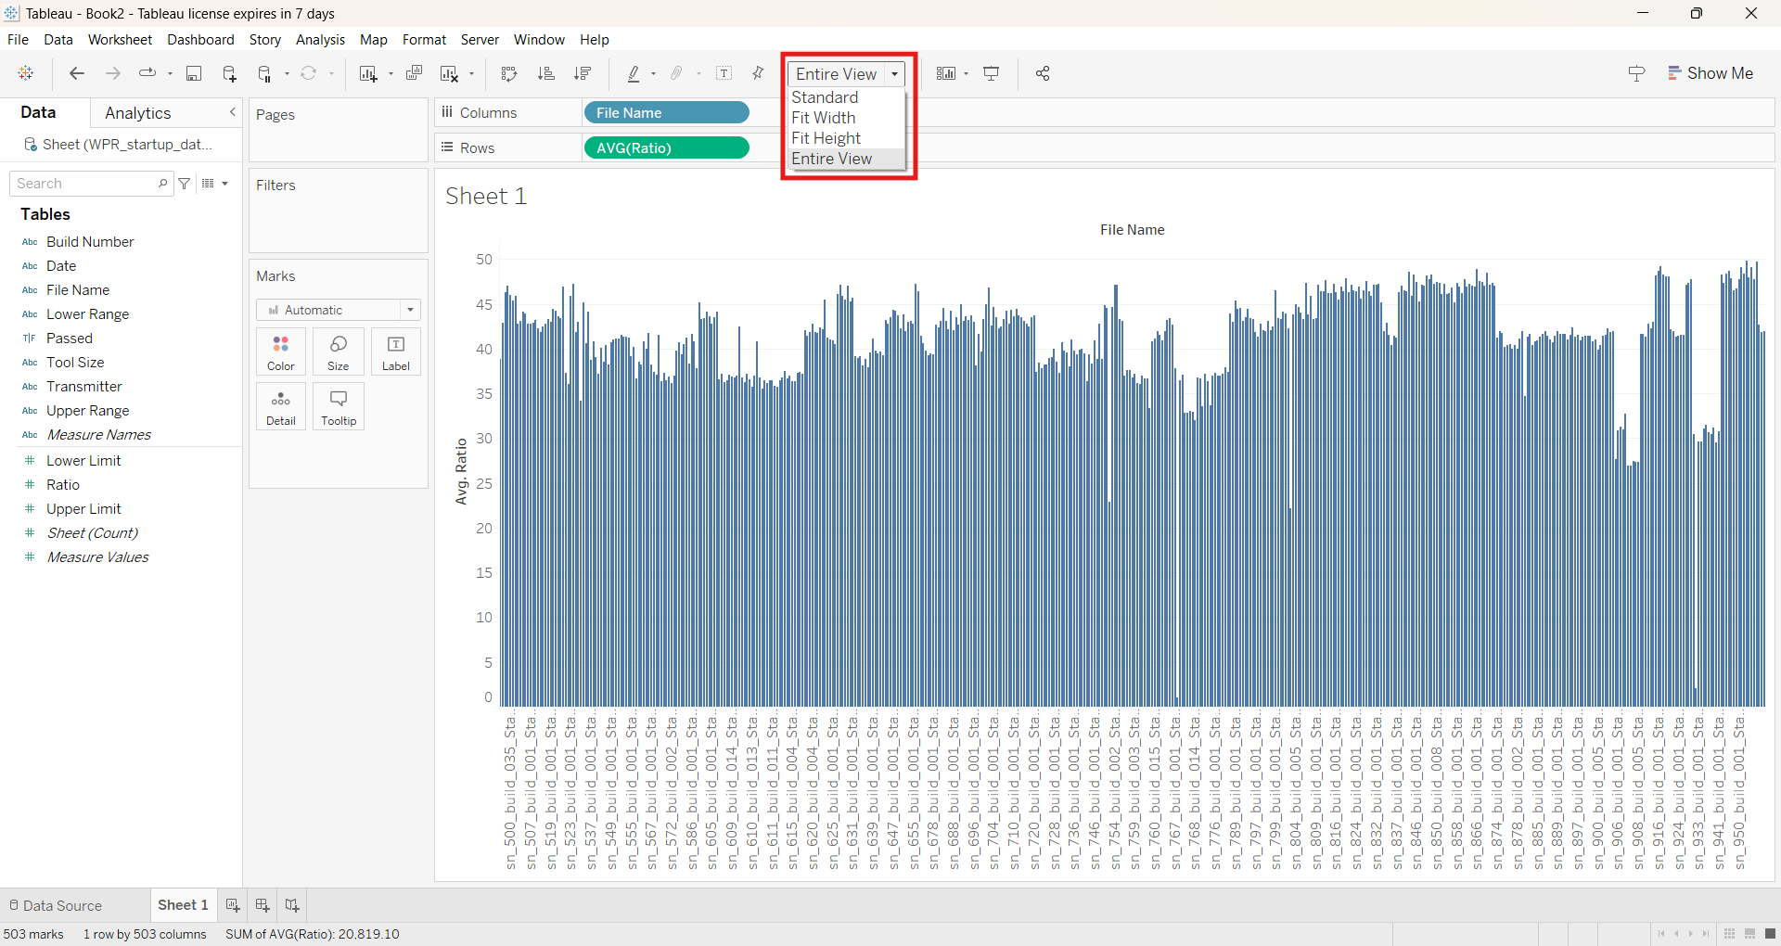

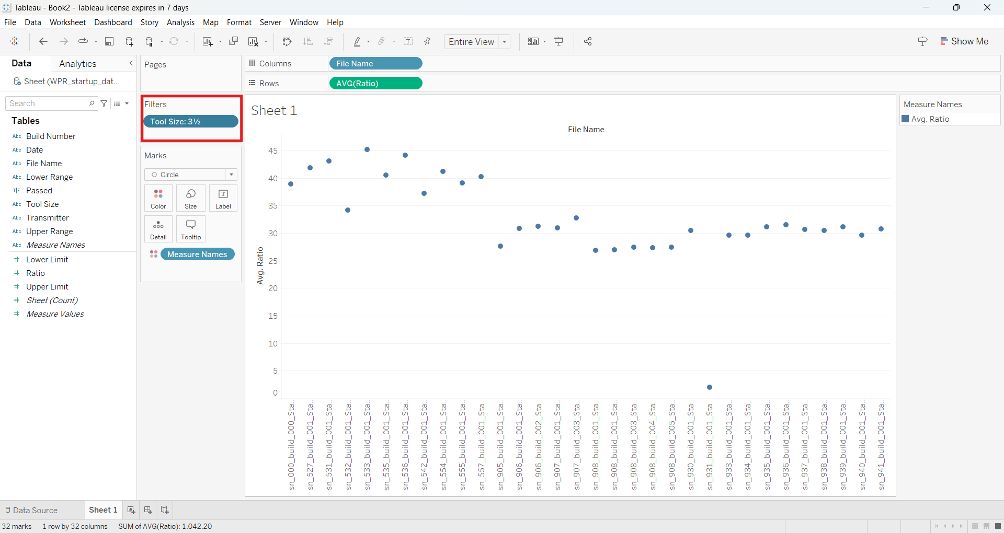

You can apply filters to the data by dragging variables into the “filters box”.

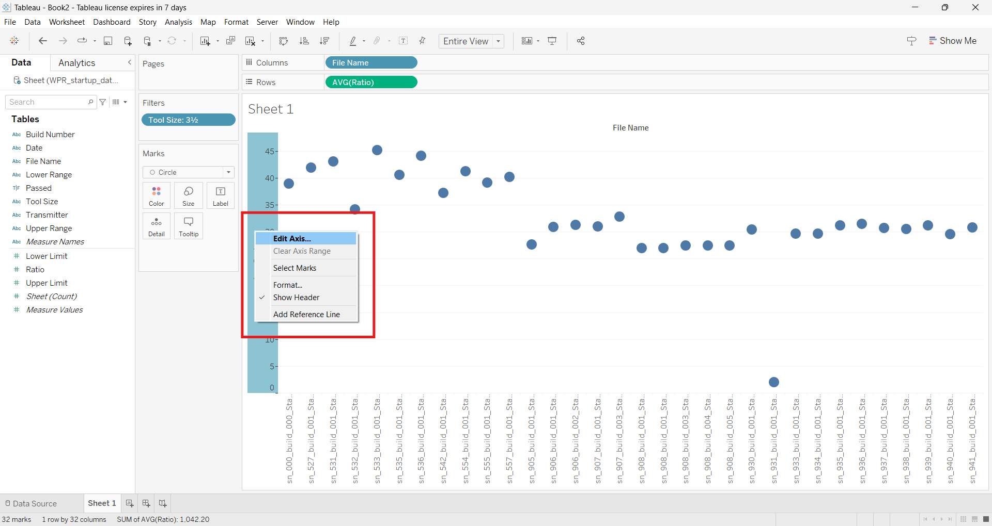

Right click on an axis in order to edit the scale of the axis.

Click create new worksheet at the bottom of the screen to create a new visulazation of the data. 